WEB ADMINISTRATIVE AREA (for companies)

* **Personal data**
  + List of employees
  + Employee card
* **JOBperson + JOBshare**
  + Categories list
    - Split by
      * JOBperson
      * JOBshare
  + Add new category
    - Checkbox
      * JOBperson
      * JOBshare
    - Name
  + Edit existing categories
  + Delete categories
    - You can delete a category only if it has no associated message (JOBchat)
  + Default contents - JOBperson
    - Paycheck, Contracts, Shifts / Working hours, Full holidays, Leave, Convocations of health surveillance visits, Welfare
  + Default contents - JOBshare
    - CCNL, Disciplinary Code / Ethical Code, CIA, Trade Union Agreements, Regulations, Smartworking, Trade Union Communications, Health-Safety Protocol, Privacy Notice

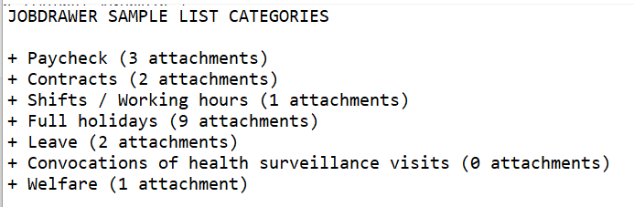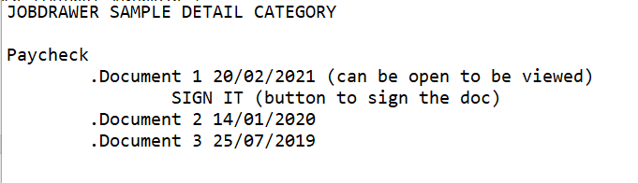

Using Laravel mysql .

jobdrawer is a container of documents

4:53 AM

grouped by categories

4:53 AM

if you started developing the admin area, this would be much more easier to do and understand

4:54 AM

app depends by tha admin area

4:54 AM

in my mind, while designing the app, i thought that i have to do first admin area, than app

4:55 AM

technical document i sent you infact, has as order before the admin area and then app

4:55 AM

you can do reverse anyway, but it is little more harder to understand

4:55 AM

about jobdrawer you need to focus in one important thing

4:56 AM

the document that the admiin sent to a employ are strictly confidentials and need to be signed by the employe that receive it

4:56 AM

in job drawer there is the list of document

4:57 AM

and if there is some document not signed, he need to do it using the sign by sms code

4:57 AM

you can well understand the app intelligence if you read in the document the admin area functionalities

5:00 AM

for example in admin area when sending a message and adding a document, admin need to set this

jobdrawer contains your personal documents jobwall contains documents shared for all the company employes

so jobdrawer and jobwall are quite the exact same sections. but the first with personal documents, the second with shared documents